Visiting Capital E PlayHQ

Introduction
We are visiting Capital E to see PlayHQ.
PlayHQ opens at 9.30am from Monday to Saturday.
PlayHQ is open from 9.30am – 12pm, and 1pm – 3.30pm.
There are a lot of different things to see there.
The theme of PlayHQ changes twice a year so we can see and play with new things.
The theme in PlayHQ at the moment is called Ngā Taniwha o Mua, and is based on the taniwha that swam in Wellington’s harbour a long time ago.
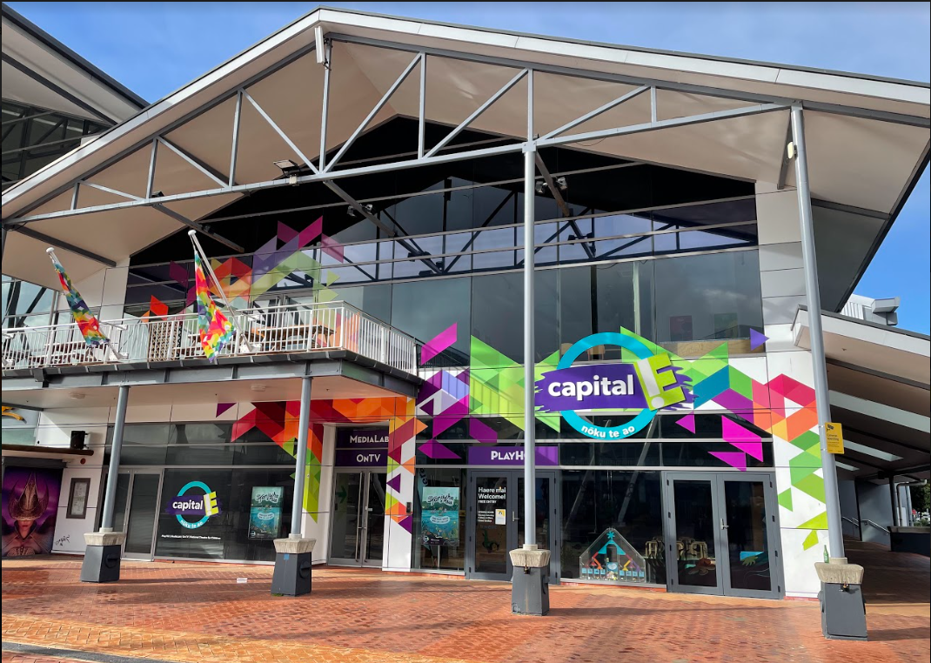

Entrance
When we arrive:
We’ll see a glass door. We pull it to open.
We’ll see coloured shapes and sea creatures on the windows and a poster that changes every season.
We’ll see a roped off area where we can park our prams and scooters.
The roped off area for prams and scooters is safe and visible from inside.
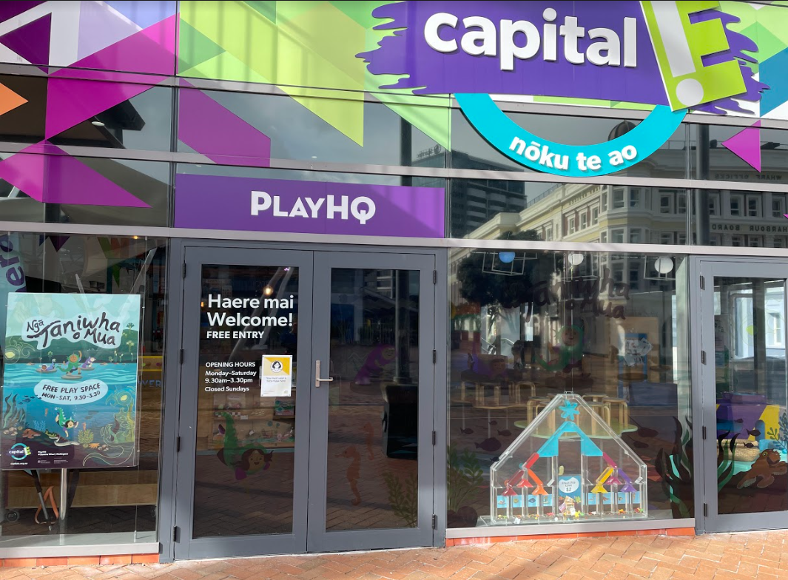
Front desk
When we enter we’ll see the front desk.
There are helpful staff behind the desk called Visitor Services hosts.
Visitor services will keep our items safe.

Helpful Staff
We’ll see a visitor services host behind the front desk.
If we have questions about PlayHQ they can help us find an answer.
We can ask them where quiet zones are, or any questions about PlayHQ.
We might see different hosts each time we visit.
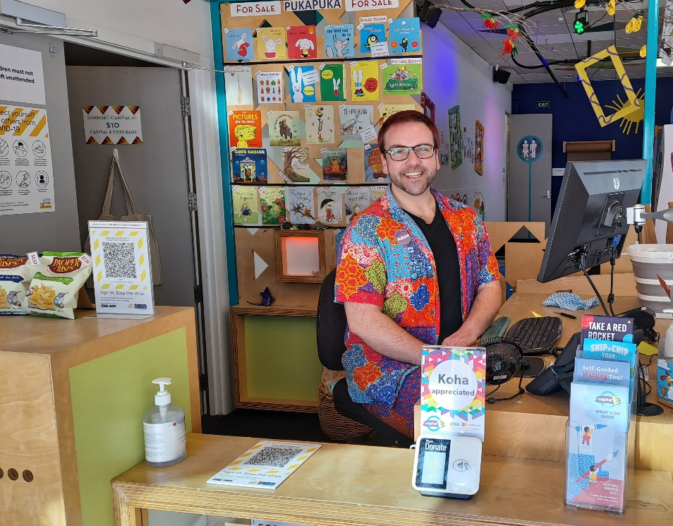

Moving around PlayHQ
PlayHQ is on the ground level.
We can find toilets through the door at the back of PlayHQ.
There is a family room next to the toilets we can use with our caregivers.
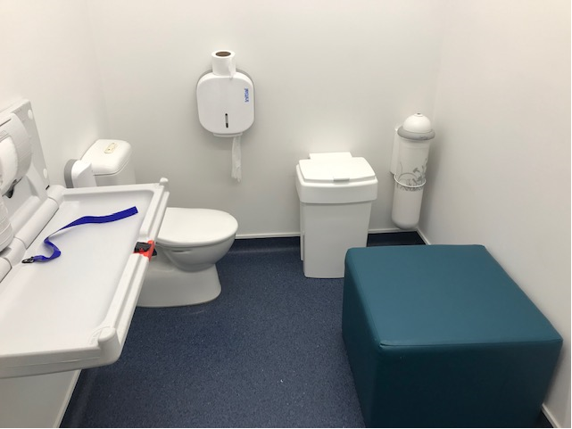

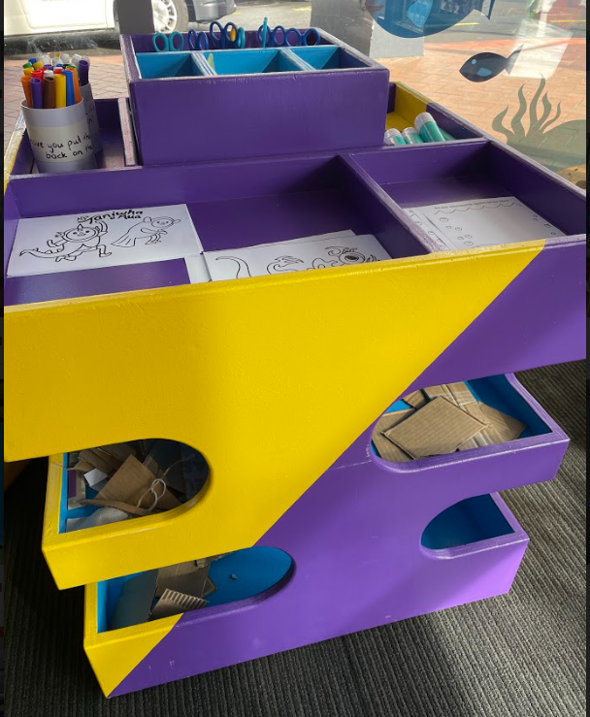
Craft tables
At the front of PlayHQ there are two tables we can sit at to make crafts or eat food.
We can find craft materials in the craft caddy.
Materials we can find include fun activities, felt pens, scissors, glue, coloured paper and cardboard.
There is also a green and orange speaker on the green table that quietly tells the story of the taniwha Ngake and Whātaitai. We can listen to this while sitting at the green table.
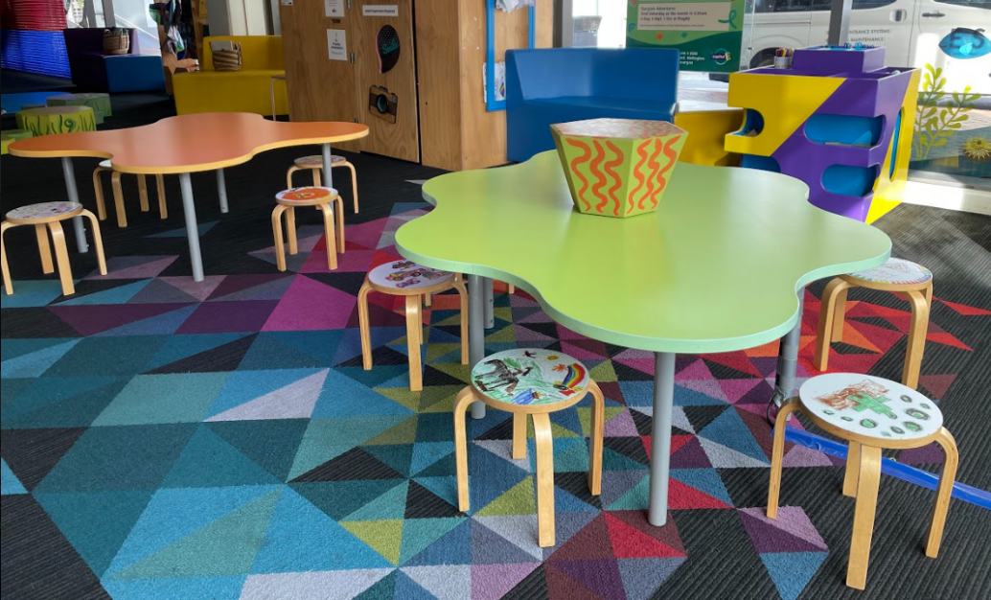

Stepping stones
There are green stepping stones of different sizes secured to the ground.
We can jump or walk between stepping stones.
We can pretend to splash into the pond from the stepping stones.
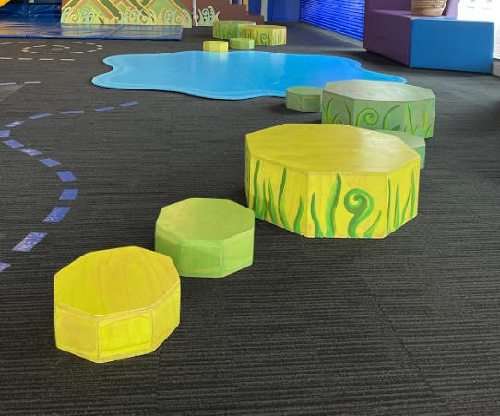
Blue puddle
There is a blue puddle on the ground that looks like the edge of the water. There are taniwha projected onto the puddle.
If we walk through the puddle the projection will change and move where we’ve walked.
The projector hangs on a bar above us, it is firmly attached and will not fall down.
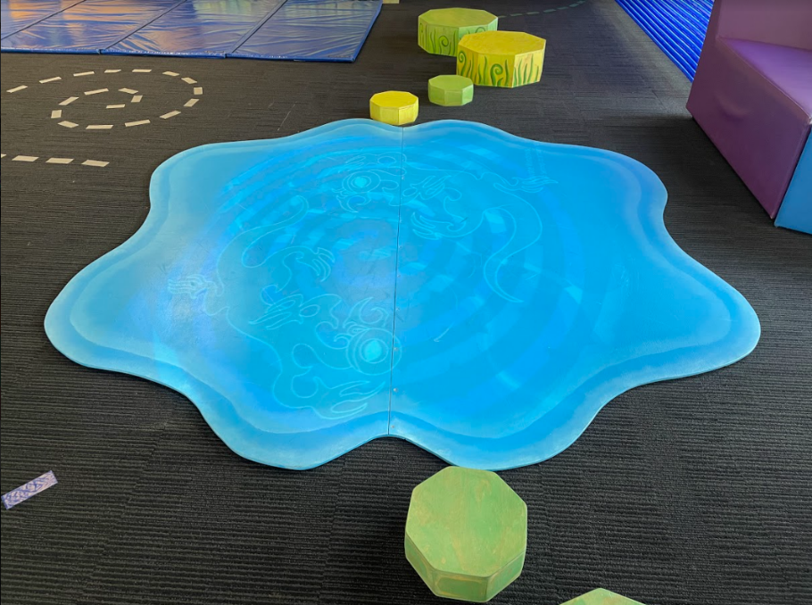
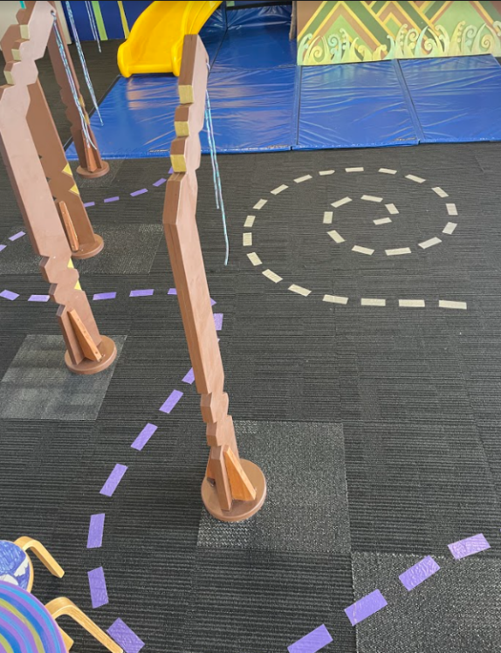
Ribs and swirls on ground
There are swirls on the ground that we can follow if we want.
There are brown structures we call “ribs” that are bolted to the floor. We can follow the path weave between them if we want.

Climbable mountain with slide
There is a structure at the back of PlayHQ that we can play on.
We can climb up the stairs on the right and look out over PlayHQ.
We can choose to go back down the stairs, or down the slide.
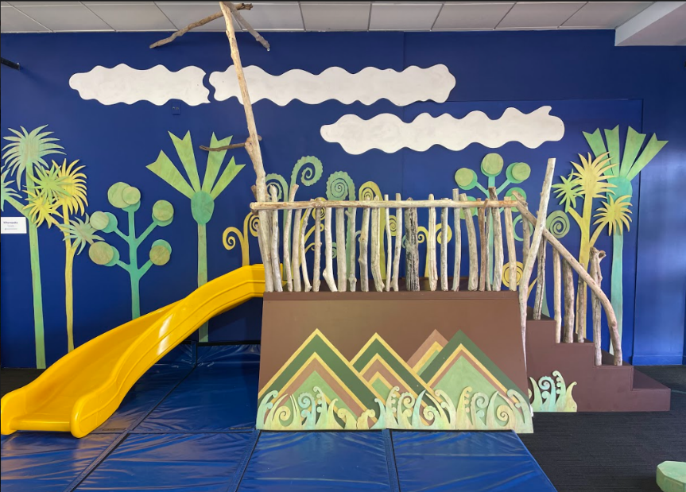
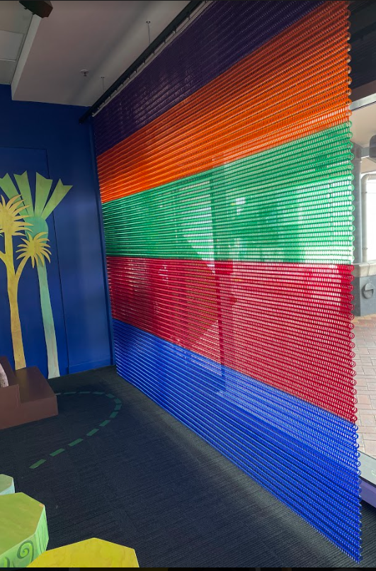
Kaynemaile curtain
There is a curtain made of plastic mesh hanging next to the mountain down the side of the room. It is securely hung ad will not fall down.
We can play with the curtain, and as it moves watch the ripples and listen to the sounds it makes.

Puzzles
There is a small table in the middle of the room with some puzzles we can play with.
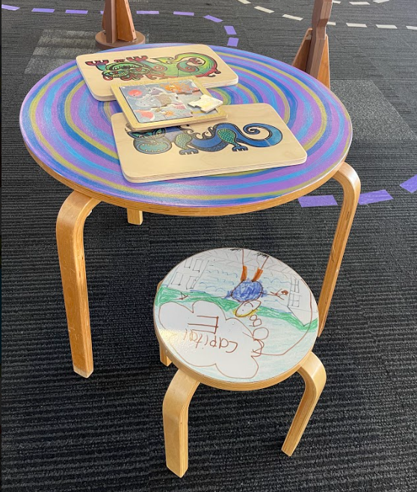

Under the sea mural
There is a big painting on the wall that shows what under the water could look like.
There are lots of sea creatures on this mural to find, and their names are next to them in Te Reo.
There are special magnets with sea creatures on that we can place wherever we want on the mural.
The magnets live in trays on the floor when they aren’t on the mural.
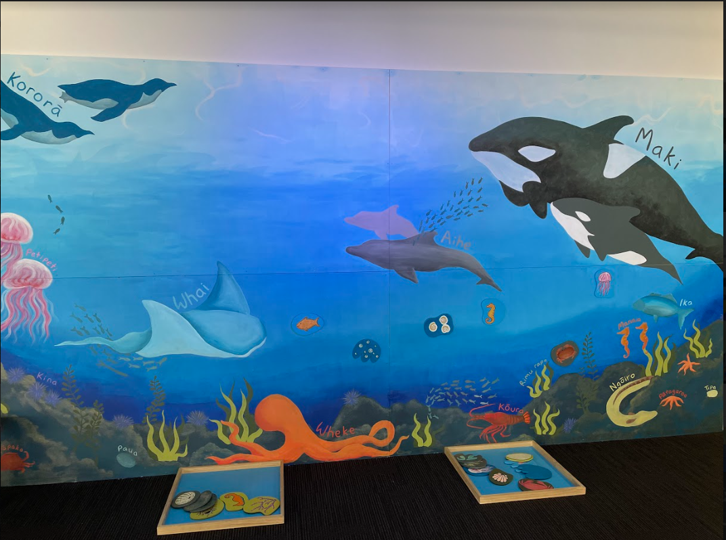

Baby corner and interactive wall
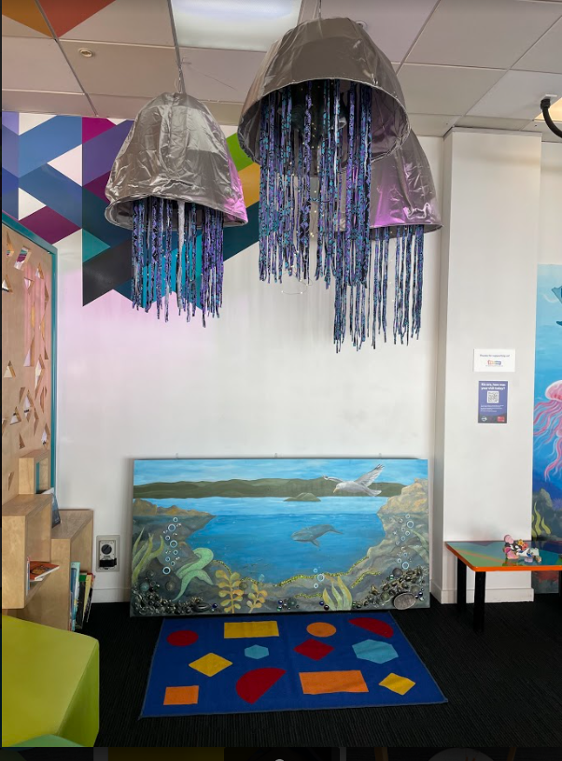
There is a corner behind the front desk that has seating for caregivers and babies.
There is a painted interactive wall that we can touch and play with. There are different textures to feel down the bottom. If we touch the painting it may make different sounds.
The picture tells us what the sound will be.
The bird makes a bird call. The while makes whale sounds. The water sounds like waves. The rocks sound like a gentle earthquake.
There are some jellyfish floating above us. These jelly fish are secured to the ceiling and won’t fall down.

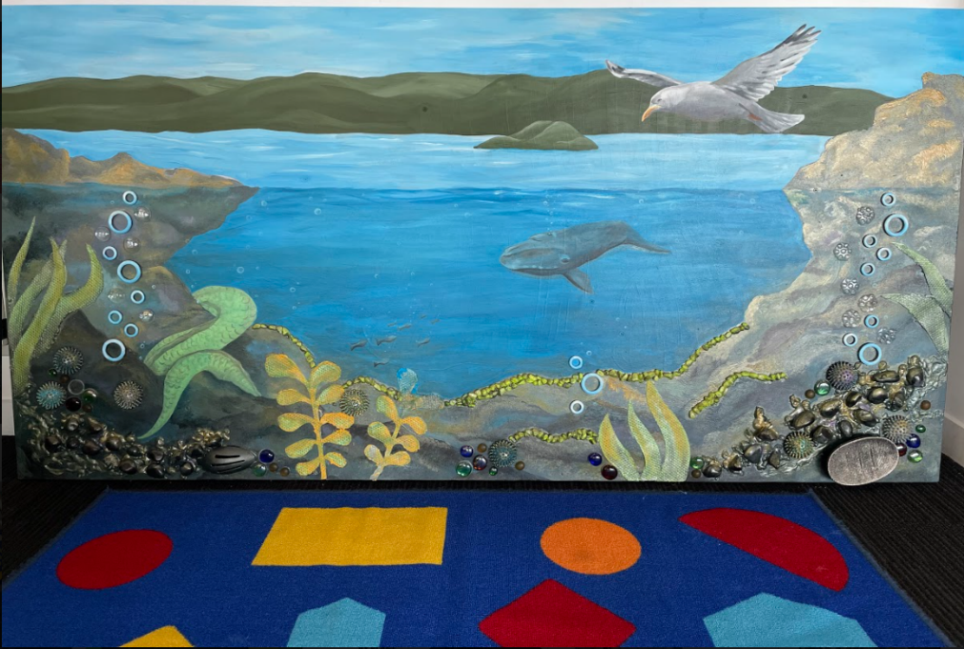

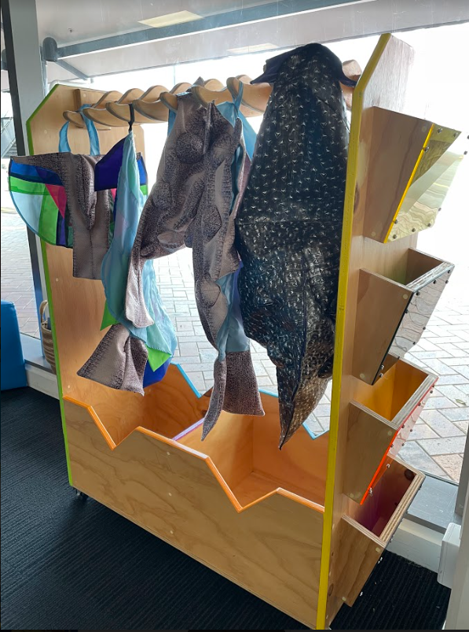
Costumes
There is a rack of costumes that we can put on.
There are smaller costumes for babies, and larger costumes for toddlers.
The costumes are taniwha themed, some have wings, some have hoods, and some have tails.

Photobooth
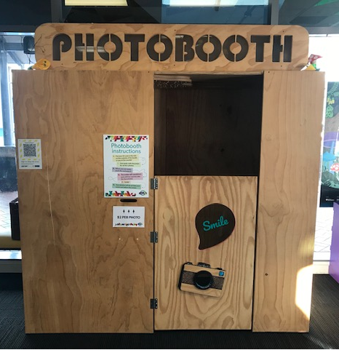
There is a photobooth with a door that stays closed.
We can use the photobooth, but it costs $2 per photo print out.
We can sit on the seat inside the photobooth and use the props in the basket.
We can press the red button to take the photo, it will count down from 3.
Four photos will be captured.
Each set of four photos gets printed out for us to take home, it takes about 30 seconds to print.

