Social Story

Visiting
Capital E
MediaLab

My visit to Capital E’s MediaLab

My name is:
……………………………………………….
I am visiting Capital E on:
…………………………………………….
My class will be doing a programme called:
………………………………………………………….
We will get to Capital E by:
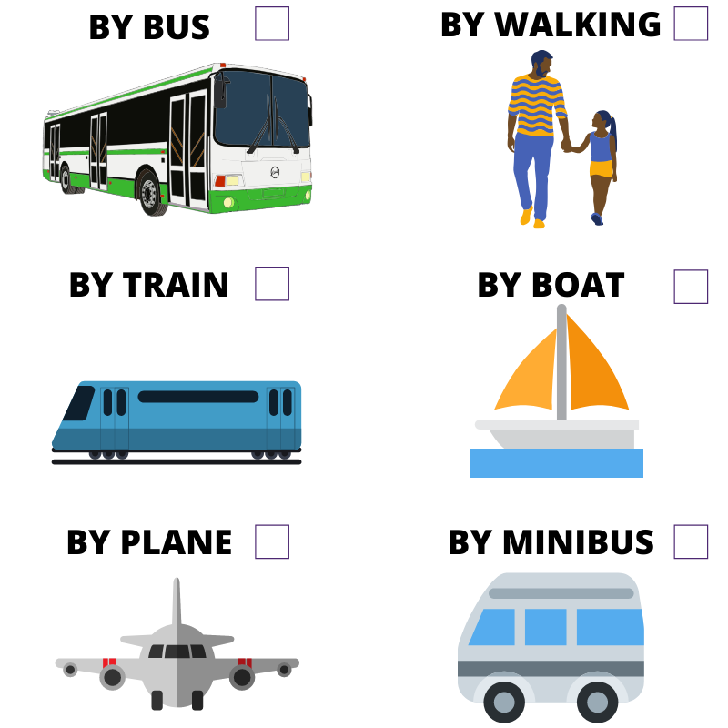

Introduction
We are visiting the MediaLab studio at Capital E
We will be in a room with computers, spinning chairs, a big projection screen and lots of colourful lights on the walls.
My class will be using the computers to have a fun and creative digital experience.

Entrance
When we arrive at Capital E:
We will see a building with big glass doors and windows with colourful stickers.
We might see prams parked outside the building. We might see parents with their children.
We will see a balcony on the second floor with colourful flags.
We will stand under this balcony with our class, in front of the big Capital E logo on the window.

Helpful People

A Capital E digital tutor will meet us outside the building.

There might be one or two Capital E tutors helping us during our session.

We might see different tutors each time we visit.

The tutor will greet us and explain Health and Safety to us.

They will then give us some instructions.

The tutor will be friendly and I can ask them or one of the adults with my class if I have any questions.
While I am at Capital E I am expected to behave well and have fun.
I will need to listen to my teacher and to the tutor and follow the instructions they give me.
If I want some time out, I can talk to my teacher who will help.

Getting Around
There are two levels at Capital E.
The MediaLab Studio is on the first level.
Play HQ is the space for pre-schoolers on the ground level.
The toilets are on the bottom floor of Wellington Museum, the blue building to the right of Capital E.
To get to MediaLab, we will need to walk through the sliding glass doors to the left of Capital E, underneath the TSB Bank Arena sign.

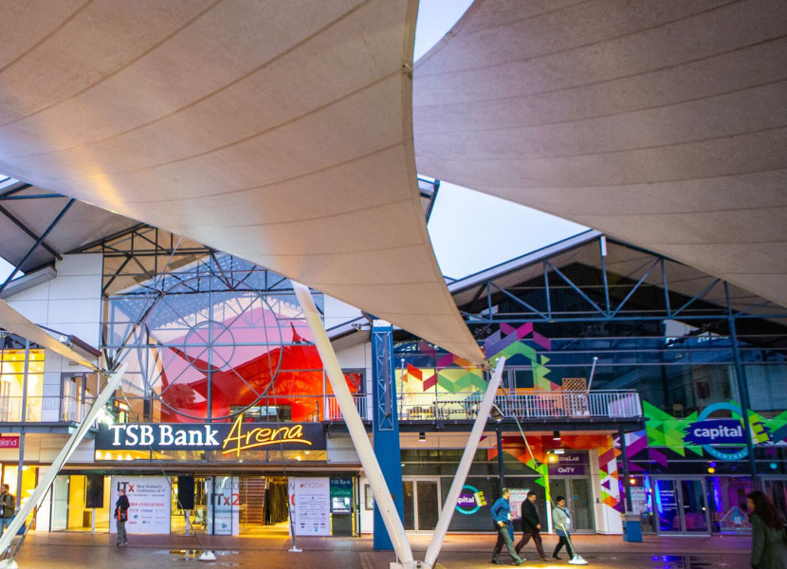

Inside the Building

When we enter the TSB Arena building, we will see another set of sliding glass doors.
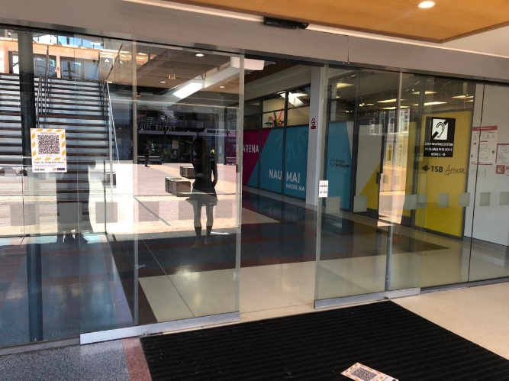
We will walk through these doors and see a big staircase.
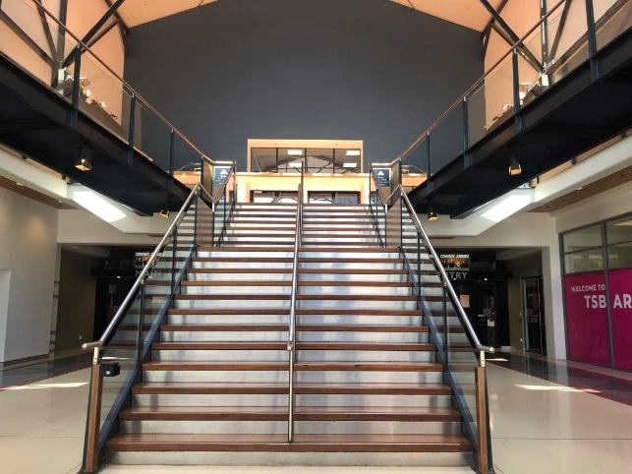
We will either follow the tutor up the stairs or someone will take me up in the lift to the studio.
The door to the MediaLab studio is at the top of the stairs on the right side.
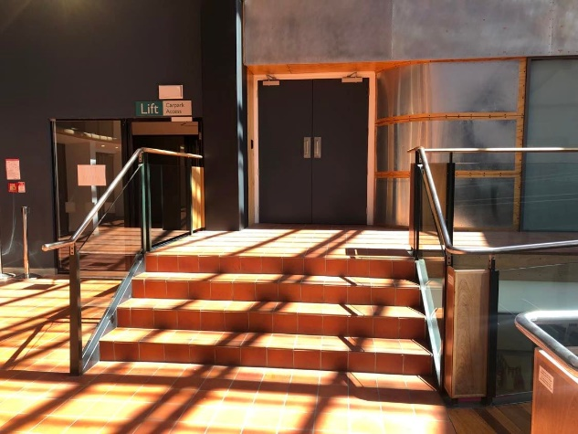

Inside the MediaLab studio

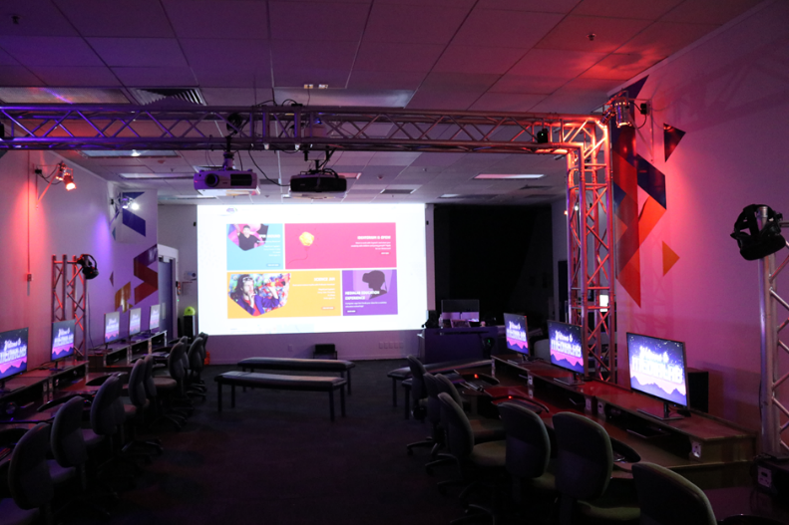

When we enter the studio, I will see a wooden box next to the door. This is where I will leave my bag for the duration of the class.
Inside the studio, we will see a dark room full of computer screens.
We will see lots of colourful triangles and lights on the walls.
There will be a large projection on the wall at both ends of the room.
The tutor will have a workstation near the door beside a projection screen with two screens facing away from the student workstations.
The tutor workstations will be sectioned off with queue dividers. The tutors will stay behind these dividers during the session so that they can social distance from our school.

During the MediaLab session

We will walk but not run to a seat at a student workstation.
If there are not enough workstations, I may have to work with someone else as a pair at one computer. I will be able to work with a teacher or adult to arrange someone I am comfortable working with.

The computer at my workstation will be locked and will show a picture that says, ‘Welcome to MediaLab’.

The tutor will sit or stand facing me and my group from behind the queue divider and use the large projection to give us our instructions.

I will continue to sit at my workstation while listening to the tutor’s instructions. The tutor may also have some examples for me to look at on the projection screen.

When the tutor has finished giving my instructions, they will unlock the computer at my workstation so we can start the session’s activities.

While I work, I will be able to use the chat function on my computer to ask the tutor for help if I need it.

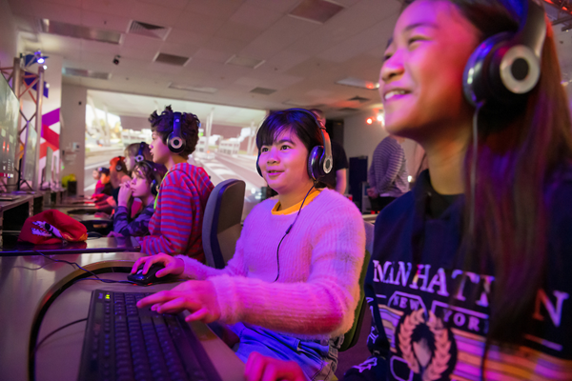

A few times during the session, the digital tutor will stop the class so they can give us more instructions.
My computer will be locked, and I will see the ‘Welcome to MediaLab’ picture on my screen again. This means the tutor wants to stop working and listen to the next part of the lesson.
Although my computer is locked right now, when the tutor unlocks my computer again, the work I was doing will still be there.
The tutor will sit or stand facing me and my group from behind the queue divider and use the large projection to show us the next part of the session.

I will continue to sit at my workstation while I listen to the tutor.

Once they are done giving instructions, the tutor will unlock my computer and I can keep working on my project.

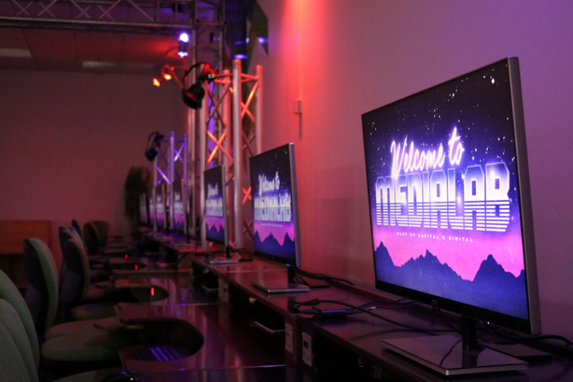

Food/ Drinks Break

MediaLab has a lot of delicate equipment so we will keep our food and drinks in our bags.

If I am thirsty or hungry, I will tell my teacher.

I will have my drink or eat my food outside of MediaLab.

Toilet Break

If I need to use the toilet, I will tell my teacher or another adult and they will take me to the Wellington Museum bathrooms.

To find the toilet, we will go back out the door into TSB Arena. We will use the TSB Arena stairs or the lift to get the ground floor.

We will go out through the glass doors and turn left.

We will see a blue building in front of us and walk towards the entryway that has a sign above it that says “Museum Entrance”

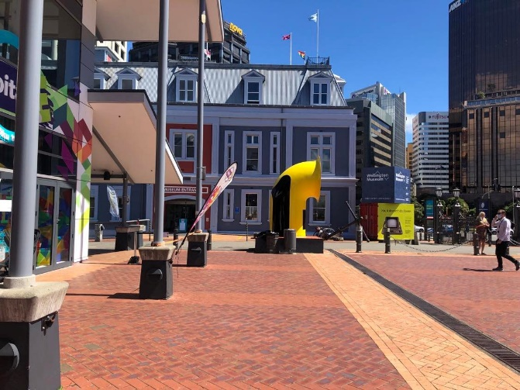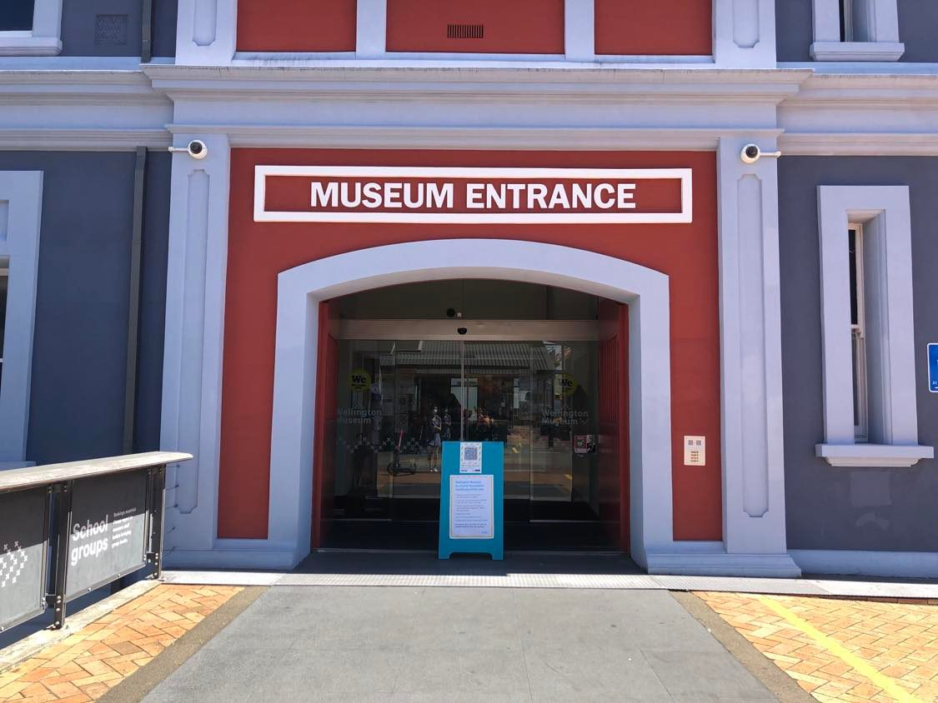

We will walk through the glass doors and turn left to go to the toilets.

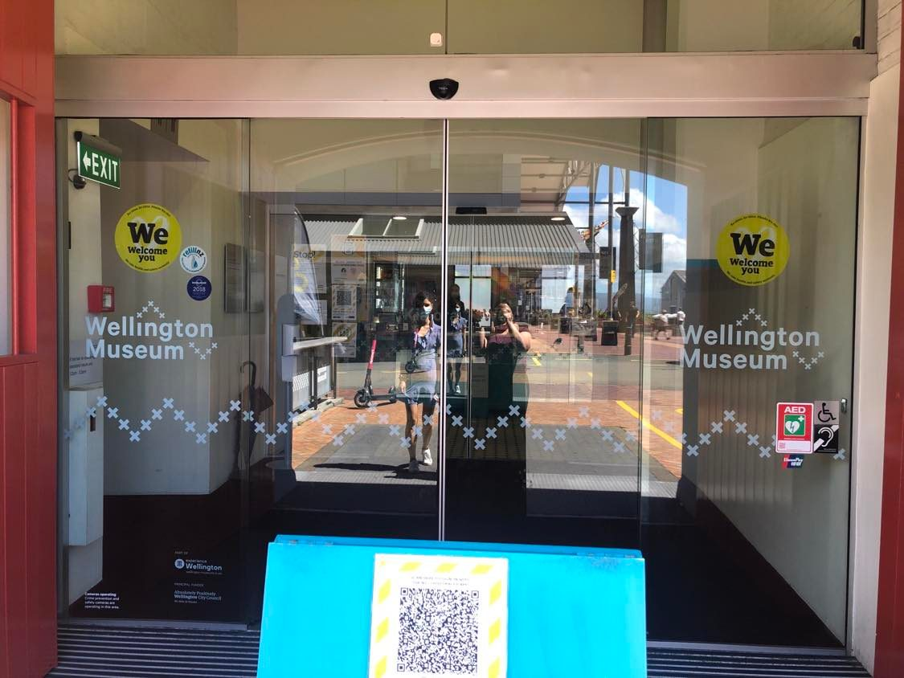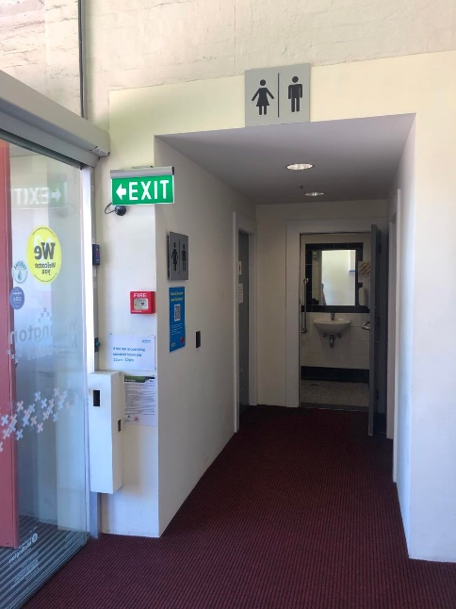

There may be some other people in these toilets as they are shared with Wellington Museum.

I will go into the male or female toilets and use the cubicle that has the student toilet sign.

If there is a fire alarm when I am in the toilet someone will be waiting to assist me to join the rest of my group.

Ending the MediaLab session

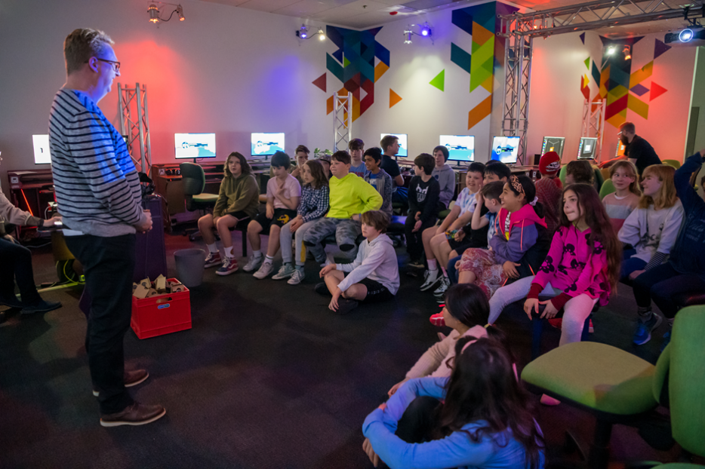

At the end of our MediaLab session, our computers will be locked for the last time and our tutor will show us how to download and view the work I have made once I get home.

I will learn how to find the software, app or website I have used to create my work so I can keep using it at home.

There will be some time to ask any questions I might have.

After we have finished, we will collect our things from the wooden boxes and leave using the door to TSB Arena.

We will walk back down the TSB Arena stairs make our way out of the building.

My teacher or group leader will give me the instructions for how to do this.

I can ask them if I have any questions.

